19PW13,LABTEST-1

1a)

i.)

function:

function [ Area ] = sarea(h,r)

%Returns surface area of cylinder

Area=(2*pi*r*h)+(2*pi*r*r);

end

>> sarea(10,2)

ans =

150.7964

ii)

%equation = input('Enter the equation - ', 's');

%surface_area = input('Enter the surface area - ');

[r,h] = heirad('2*h -20*r ==0',100)

fprintf('radius - %f\n height - %f\n',r(2),h(2))

function :

function [radius,height] = heirad(equation,surface_area)

    syms r h;

    S = solve(equation,surface_area == 2*pi*r^2 + 2*pi*r*h,r,h);

    radius = S.r;

    height = S.h;

end

1b)

>> fplot('(x.^2+1)/(5*x-3)',[-4,4],':or','MarkerEdgeColor','y','MarkerFaceColor','g','LineWidth',3,'MarkerSize',14);

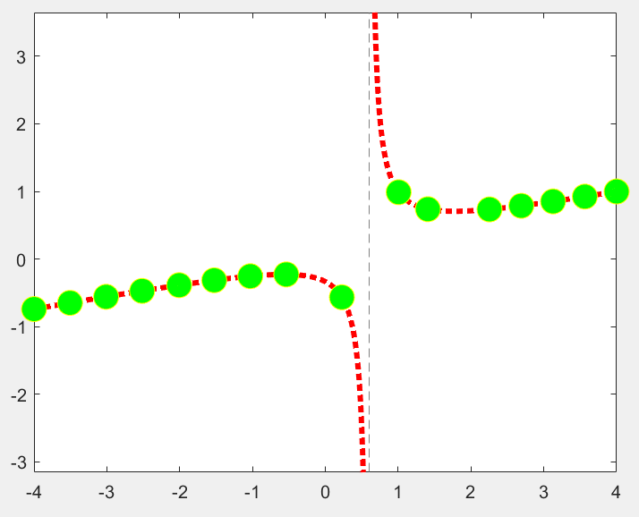

2a)

Function binomial:

function [ mean,var ] = Binomial(n,p)

%UNTITLED5 Summary of this function goes here

% Detailed explanation goes here

mean=n*p;

var=n*p*(1-p);

end

function geometric:

function [ mean,var ] = Geometric( p )

%UNTITLED7 Summary of this function goes here

% Detailed explanation goes here

mean=1/p;

var=(1-p)/(p.^2);

end

function poisson:

function [ mean,var ] = Poisson( lambda )

%UNTITLED8 Summary of this function goes here

% Detailed explanation goes here

mean=lambda;

var=lambda;

end

cmd window:

n=3

s2='binomial';

s3='geometric';

s4='poison';

for i=1:n

Type{i} = input('Enter word:\n','s');

s2='binomial';

if(strcmp(Type{i},s2))

n=4

end

end

if(strcmp(Type{1},s2))

n1=Type{2}

p1=Type{3}

n=str2num(n1)

p=str2num(p1)

mean=n*p

variance=n*p*(1-p)

end

if(strcmp(type{1},s3))

p1=Type{2}

p=str2num(p1)

mean=1/p

variance=(1-p)/(p*p)

end

if(strcmp(type{1},s4}

lambda1=type{2}

lambda=str2num(lambda1)

mean=lambda

variance=lambda

end

2b)

for i=1:1000

if mod(i,2)==0

if mod(i,5)==0 && mod(i,7)==0

if mod(i,3)~=0

disp(i)

end

end

end

end

OUTPUT :

70

140

280

350

490

560

700

770

910

980